October 2020 Newscast – Central Iowa Beekeepers Association

Fall Greetings, Members!
Winter is coming fast and we only have a month or so to get our bees ready for the harsh conditions. We have included an attachment from Betterbee - a 10-point checklist of things to do to get ready for winter. Good recommendations and reminders.

In talking with other beekeepers -- both commercial and hobbyists -- it was a good year for honey production for most of us. Spring Valley Honey Farms and Ebert Honey both have said it was a good year for them. A few, however, did not. Why, you ask? Curt Bronnenburg said the dry hot conditions he feels contributed to good nectar flow. This was the best year in 20 years for him, he said. Phil Ebert said it was a great flow for him as well but his son's bees did not do as well for some reason.

In my own bee yards some did very well whereas one of my yards did not produce any honey at all. Those hives really struggled to stay alive. Why? Who knows. Perhaps due to my splitting my hives too late in the spring or someone sprayed something toxic in the area or ?????

The Board has decided to not have any in-person meetings due to the virus situation. We did put together an informational video featuring Arvin Foell with a follow-up zoom meeting to ask Arvin questions about it. Hopefully you were able to watch it. Thanks Arvin, Linn and Jeremiah for putting this together. We are interested in your opinion about this. Please contact us with your opinion.

We are in the discussion stage of future virtual meetings so stay tuned. This is a tough year for organizations to stay connected while still staying safe. Your membership is important to us and we want to provide a value to your membership.

I want to mention, one of the scheduled Winter Seminar speakers, Larry Conner, has a huge book sale. It was unfortunate that Larry could not make it due to the snow storm but at least you can read his books at a discount.
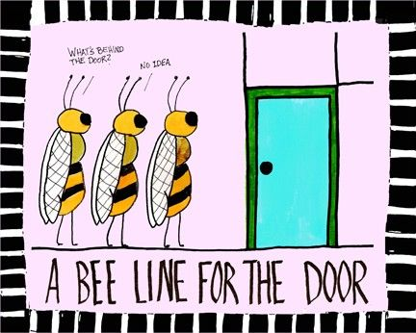
Finally, let's see how 2020 has treated us --
- A HUGE winter storm caused havoc with our winter seminar!!
- Then the Covid 19 virus pandemic caused us to cancel all of our in-person meetings.
- Then the derecho storm hit and a lot of Central Iowa Beekeepers had hives that were blown over. Some of them did not survive -- depends on how quickly the beekeeper got to them.
It has been tough on us but with resolve we can get through this year.

Being a beekeeper we are naturally socially distanced so enjoy your bees, review the 10-point checklist from Betterbee that is attached to this email, and have a great fall.

Jamie Beyer, CIBA President

